Virtual Reality Interfaces for 3D model reconstruction and sharing

**Student: Andrei-Alexandru Bunea**

**Supervisor: Prof. Anthony Steed**

MSc Computer Graphics, Vision & Imaging

September 2023

This report is submitted as part requirement for the MSc Degree in 'Computer Graphics, Vision & Imaging', at University College London. It is substantially the result of my own work except where explicitly indicated in the text. The report may be freely copied and distributed provided the source is explicitly acknowledged.

# Acknowledgements

I would like to express my profound gratitude to Professor Anthony Steed, my supervisor, for his invaluable support throughout the whole collaboration. His guidance and mentorship have been instrumental in successfully finishing this project.

I would also like to thank Nels Numan and Ziwen Lu, teaching assistants of the Virtual Environments course, who guided me in the early stages to find and design the idea that was implemented in this final project.

Finally, I would also like to thank my family for their unconditional and unwavering support. They have been the driving force behind every step of my journey, shaping me into the person I am today.

# Abstract

In recent years, 3D reconstruction has revolutionised various industries, proving to be a transformative practice in scientific research, e-commerce, and beyond. Studying a 3D model has proven more useful and intuitive than 2D images in analysing objects, helping professionals improve their expertise in medicine, archaeology, art, and many other fields.

This immersive experience not only enhances the assessment of virtual objects but also bridges the gap between the virtual and physical worlds. The integration of this technology has revolutionized the way professionals approach their work, enabling them to gain unparalleled insights into complex structures and artefacts. However, the reconstruction is done mostly by professionals that are passionate about photogrammetry and possess skills and software for 3D reconstruction and can later choose to publish their work on specialized platforms for 3D portfolios such as “Unity Asset Store” or “Sketchfab”.

This project comes as a solution for users who would like to create their own 3D models without having any prior knowledge of photogrammetry, visualize the results using a virtual reality platform, store their work and easily share it with others.

The project encompasses a web-based user interface acting as a social media platform where users publish 3D models based on uploaded images or videos, a structure-from-motion 3D reconstruction pipeline using “Meshroom”, and a Unity-based application for VR visualization. The VR application allows users to immerse themselves alongside the reconstructed 3D objects, enabling them to inspect the models from various angles and distances.

The project's methodology combines image processing, computer vision, and VR development, resulting in a robust and user-friendly system. Throughout the development process, a thorough review of related literature was conducted to ensure the project's alignment with current advancements in VR applications and photogrammetry.

The evaluation of the system involved user feedback and usability tests, providing valuable insights into the overall effectiveness and user experience. The results demonstrate the system's ability to generate accurate 3D models and deliver an engaging VR experience to users.

Contents

Acknowledgements 2

Abstract 3

1. Introduction 5

1.1. Motivation 5

1.2 Photogrammetry 6

1.3 Structure from Motion 9

1.4 Virtual Reality 10

1.5 Project structure 13

1.6 Structure of the Report 15

2. Literature Review 16

2.1 About Structure-from-Motion and Meshroom 16

2.2 Structure-from-Motion Applications 18

3. Implementation 23

3.1.1. Web Application Implementation Details 23

3.1.2 Presentation of the Web Application 24

References 37

# Introduction

## Motivation

In today’s rapid technological advancement, scientists and researchers have vastly improved their analysis by replacing the ordinary image interpretation with a more comprehensive concept: 3D models.

Using a virtual entity of a physical object and a VR visualisation tool simulates the sensation of looking at real-world objects. Immersing the user in such a way enables in-depth examination and investigation, as it confers a holistic understanding of the object, rather than the analysis of a batch of scans or images taken from different points of view. Moreover, the hands-on experience provides the researchers with a boost of confidence in their expertise, as they are more assured when working with real-world models.

Three-dimensional (3D) modelling has become a transformational force in today's quickly changing technology landscape, having a significant influence on a variety of industries from education to cultural preservation.

The goal of this project is to reduce the gap between the common users who do not possess advanced skills in photogrammetry, and the 3D model creation realm, providing a reliable and easy-to-use platform for 3D reconstruction and model sharing. Moreover, this project is investigating the complex interactions between user-generated 3D models, immersive visualisation and their many applications.

While there are a significant number of tools for either structure from motion reconstruction or VR visualisation of 3D models, there is no such platform that combines both. Moreover, each one of these activities is performed by professionals who own 3D reconstruction software and have advanced expertise in how to perform a reconstruction algorithm or how to create a VR scene where entities can be observed.

In addition, the industry currently lacks a platform for 3D model sharing that is not oriented towards professionals. Not only there are a couple of websites that provide the opportunity for 3D model browsing, but the most frequently used applications such as “Unity Asset Store” [1] or “Sketchfab” [2] require the designers to perform their own 3D model creation process before uploading the results to their portfolios.

Therefore, the innovation that this project brings to the field is a democratic and accessible process for 3D model production, sharing and exploration by utilising the capabilities of 3D reconstruction complex algorithms, advanced software, and virtual reality. By following this approach, users are relieved from the burden of mastering state-of-the-art algorithms, allowing them to fully enjoy the benefits of creating and exploring virtual representations of real-world models.

## 1.2 Photogrammetry

Photogrammetry is a dynamic and complex process that combines multiple image processing algorithms to create 3D models from sets of overlapping images. The process aims to determine the three-dimensional geometry of the physical objects captured.

In general, a photogrammetric project involves two major steps: acquisition and preparation of the image dataset, and the process of reconstruction. The first step ensures a proper camera setup and scene properties for the desired task while capturing a collection of photos with good overlapping areas, and a full coverage of the area of interest. The preparation of the image dataset may also involve applying special filters or processing techniques to images to potentiate the features of the physical object. Whereas the second step covers the whole process that converts the images into the final 3D model, encapsulating custom algorithms from feature extraction and matching to geometric reconstruction, depth map estimation and texturing. [3]

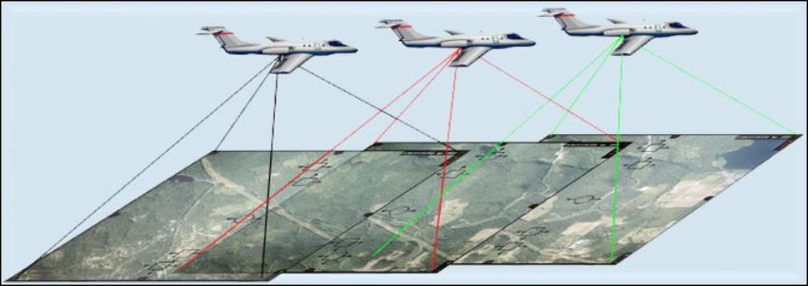

Figure 1 Aerial Photogrammetry illustration

Generally, photogrammetry is divided into aerial and terrestrial photogrammetry. Aerial photogrammetry acquires images taken from lower heights using captures from drones or balloons, medium heights using airplanes or even from astonishing heights using modern satellites. The process of acquiring images for aerial photogrammetry is presented in Figure 1. [4] Terrestrial photogrammetry is performed on images captured from the ground. The images can be acquired from far distances or close range. When photogrammetry is performed on images taken from less than 100 meters, it is considered to be categorised as close-range photogrammetry. [5]

While aerial photogrammetry is a popular practice in cartography, archaeological exploration and environmental monitoring, close-range photogrammetry has been used in detail-oriented practices such as art restoration, industrial design, and medicine.

The close-range photogrammetry takes a more intimate approach, focusing on capturing fine details of objects from a short distance. This technique usually involves the user of high-resolution cameras to photograph subjects from multiple points of view, creating accurate and detailed 3D models. [6]

Figure 2 Close-range Photogrammetry application for digital curation

In Figure 2 is presented a close-range photogrammetry application performed by the Institute of America in Transylvania, Romania in 2023 during an archaeological photogrammetry workshop. [7] In the illustration from above we can observe a multitude of high-quality images taken from different perspectives and ranges, photos that come all together to reconstruct a solid virtual representation of the targeted statue. Using photogrammetry to capture every fine detail from images of an object, not only provides a better understanding of the object but also preserves an invaluable and meticulous digital copy of the entity.

## 1.3 Structure from Motion

Structure from Motion (SfM) is a process derived from photogrammetry and encapsulates all its goals. Both SfM and photogrammetry target the reconstruction of 3D scenes or objects from a collection of 2D images. However, SfM incorporates other additional tasks such as estimating the camera position and parameters, being more concerned with capturing relative positions and orientations of images.

In photogrammetry, camera calibration and image orientation are crucial for accurate measurements and are established from the start of the experiment. Ground control points may be used for georeferencing. In contrast, structure from motion is more flexible and automated, as it does not rely on camera calibration and geolocation. Instead, it uses feature tracking across the images to determine the camera parameters. [8]

The key stages of the structure-from-motion pipeline include:

1. **Feature Detection**

This first step covers the detection of distinctive features in each image such as corners, edges, or other key points. Classic algorithms for feature detection are Harris Corner Detector and ORB.

1. **Feature Matching**

The second step is responsible for establishing correlations between features extracted in different images. Classic algorithms for this step are RANSAC and SIFT.

1. **Camera Pose Estimation**

Using the feature correlation between images, the fundamental matrix for camera calibration is estimated. From this matrix, the extrinsic and intrinsic parameters are extracted, measuring the camera position and orientation.

1. **Sparse Point Cloud Reconstruction**

Based on the information provided by the essential matrices estimated in the previous step, information about the local 3D coordinates of the mesh vertices is extracted, thus constructing a sparse point cloud reconstruction of the model.

1. **Bundle Adjustment**

This fifth step is an optimization process that refines the estimated camera poses and vertex positions, minimizing the reprojection error. This step ensures that the reconstructed 3D points align as closely as possible with the characteristics of the physical object.

1. **Mesh Generation**

Additional 3D points are reconstructed by triangulating pixels from all images, completing the point cloud of the scene or model’s surface.

1. **Texture Mapping**

This final step involves mapping the texture to every face of the mesh, using the original images as a reference to obtain similar-looking textures.

The SfM pipeline is a reliable and flexible approach to creating 3D models, recommended for projects that do not have the facilities of setting up the camera parameters. This technique has the same applications as close-range photogrammetry. Advances in computer vision enrich the technical capabilities of the SfM pipeline to produce more accurate structures, render corresponding textures and achieve a faster rendering with a smaller running time.

## 1.4 Virtual Reality

Virtual Reality (VR) represents a groundbreaking idea that involves crafting an environment where individuals can detach from their actual surroundings and immerse themselves in diverse sensory experiences. The aim of virtual reality is to provide a highly realistic immersive display that stimulates the senses of users in order to induce the feeling of belonging to a virtual scenario. Therefore, this distinctive idea enables users to engage their senses through realistic simulations of real-world experiences, all from the convenience of their home or office, and having access to multiple virtual worlds in a small device such as a pair of VR headset.

Immersion is the main goal of Virtual Reality. To achieve full immersion, users need to experience a complete detachment from reality, engaging all their senses solely within the virtual environment. To elicit immersion, a virtual environment should include four main components: sensors, simulators, rendering and display. Examples of sensors are trackers, microphones or bio-signal devices that turn physical effects into signals. VR headsets such as the Oculus Quest used in the developing process of this project rely on the controller’s sensors and the headset’s cameras to provide critical information about the user's position and gestures. The output of the sensors is passed to the simulators that simulate the virtual environment and its interaction with the user based on the data provided. Further, the renderer creates the Virtual Environment visually and produces signals, which are then transformed into physical images by the display.

Unity is one of the most popular tools for creating immersive Virtual Reality applications. It is an optimal solution for developers as its flexibility, feature-rich environment, and wide range of compatibility foster the creation of interactive and captivating VR experiences. Even though Unity was conceived initially for game development, its applications cover a larger usability spectrum, making it a cornerstone development tool for VR applications.

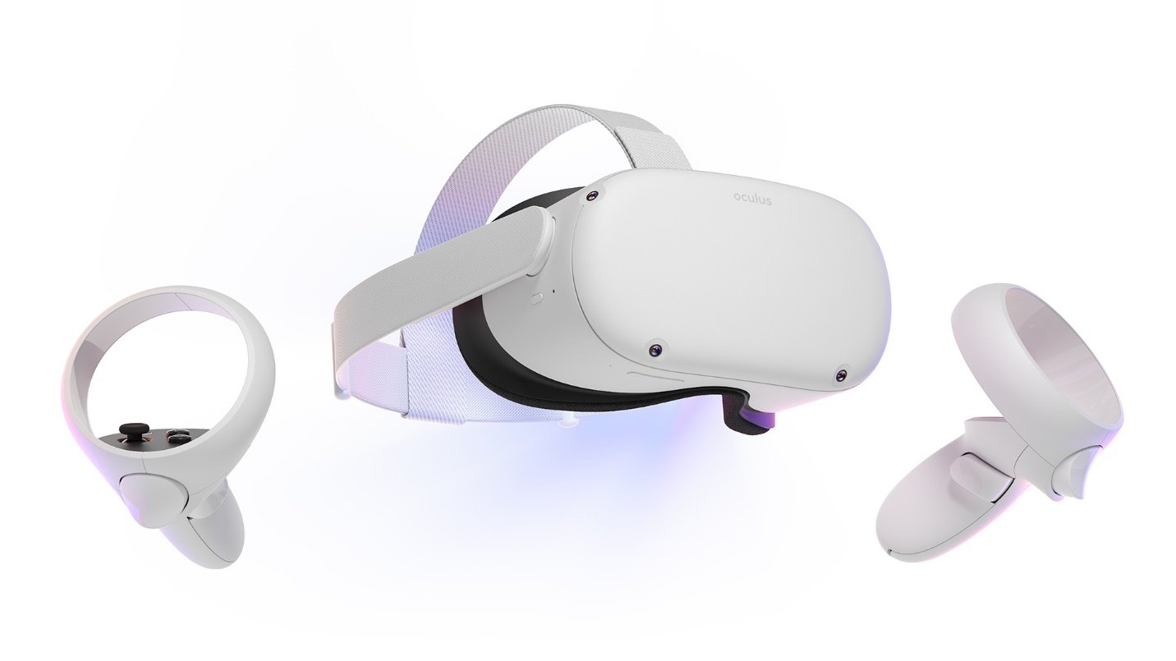

Figure 3 Oculus Quest 2 (the headset used in this project)

One of Unity’s strongest features is its integration with VR hardware, like the Oculus Quest headset used in the project. It provides special support for specialised VR technology such as the XR controllers’ tracking mechanism and actionable buttons. It also offers a specialised collection of 3D models, enhancing the performance and creativity of the projects. In Figure 3, the headset used in this project for both development and testing is displayed, as advertised on the Meta official website. [9]

Furthermore, the implementation of realistic interactions within the virtual worlds is facilitated by Unity’s physics engine which enables users to authentically interact with objects from the virtual setup. Assessing this project’s needs, Unity was chosen as the optimal platform for the development of the VR visualisation application. It provided fast protocols for the data acquired from the server at runtime, a detail-oriented interaction with the environment and an aesthetic touch on the design.

## 1.5 Project structure

The 3D model reconstruction and visualisation project is methodically organised into various components that contribute harmoniously to a coherent and efficient workflow. The process guarantees that 2D photos are successfully transformed into 3D models and transposed in an immersive VR environment. The architecture of the project includes four main components: an Angular web application, a 3D reconstruction pipeline and a Python, a Flask backend, and a Unity VR application, all components working in tandem to offer a smooth and engaging user experience.

Web Application (UI)

Angular, Node.js

VR Application

(Visualization tool)

Unity

Backend

(API + Services)

Python, Flask

MySQL

(Database)

The interaction with the project begins by accessing the web-based user interface. The frontend component is designed to facilitate friendly designed and intuitive features. To use the web application, the users need to sign up for an account or log in with an existing one. The login credentials are verified by interrogating the project’s database. After the successful validation, users are allowed to perform all the activities that the platform offers. First, there is a Dashboard component where the users upload their images or videos in order to create 3D models.

Another feature is the personal portfolio, where users can preview their work, download the models, edit their names, or delete them. In addition, users can search for other users’ profiles in the explore section, follow their work and see their 3D models. Every 3D model can be seen both in VR and also in the web application, where a scene is rendered including the targeted reconstructed object.

The second component is providing the 3D models using a structure from motion automatization on the images or video provided by the user. Using the free, and open-source Meshroom software from AliceVision, the project introduces a script that runs 13 reconstruction stages. At each stage, the pipeline’s script configures the parameters that are passed to Meshroom, having multiple scripts, one for each reconstruction step. After feature extraction and matching, camera estimation, dense scene, depth map filtering, mesh decimation and texturing, the 3D models are created and ready to be rendered in the visualisation tools.

The third component is the one that organises all the processes and data flows – the Python, flask backend. Inside the backend, the endpoints for the applications API are defined, providing routes that are used by the web user interface and the VR visualisation tool. Moreover, it processes the upload of images and videos, while preparing the input dataset for the reconstruction pipeline. In order to store details about the users, the application stores their email, name and IDs of the models in a MySQL database, that is queried by the backend when needed.

Last, the fourth component is the Unity VR application which serves as an immersive visualisation tool. The VR application provides support for login, after which the user can preview and spawn their own model and search for the portfolios of the people they follow. In other words, the application has the same features as the web application except for the signup and image upload for reconstruction. In addition, the VR application provides a unique and immersive tool that facilitates a faster and more genuine exploration of 3D models. Inside the virtual scene, the users can move around the object, rotate, scale, or translate the object in order to achieve a better understanding of the model.

## 1.6 Structure of the Report

The goal of this report is the understand the mechanics behind the implementation of the implemented tool and its use cases. In order to achieve this, the report will further describe previous implementations of structure from motion applications, the implementation of this project, its evaluation and the conclusions.

In section 2, we will analyse the literature review and examine the implementation of similar tools, as well as their usage and achievements.

In section 3, the implementation of the project will be discussed, examining step by step the processes behind the four main components: the web user interface, the reconstruction pipeline, the backend, and the Unity VR application.

Section 4 will be designated to the evaluation of the project, studying the performance of the reconstruction process and the feedback from the users that were asked to complete a form after participating in an experiment where they tested both the web user interface and the VR visualisation tool.

Last, section 5 will assess the conclusions regarding this project, its strong features and weaknesses and will consider future work for its improvement.

# Literature Review

The literature review chapter examines existing research and studies underpinning the field of 3D model creation and visualization. This chapter examines a variety of sources, from basic academic papers to groundbreaking research articles, all of which contribute to the project’s foundational knowledge. Through synthesizing these sources, the literature review contextualizes the project within technology and academia and provides guidance for innovative methodologies and strategies.

## 2.1 About Structure-from-Motion and Meshroom

Thanks to technologies such as Structure from Motion (SfM) photogrammetry, the field of 3D reconstruction has made significant progress in recent years. SfM techniques allow for the creation of precise and detailed 3D models from multiple 2D images, making it an essential tool in numerous fields.

The paper "Structure from motion photogrammetric technique" [10] presents the incredible potential of this technique, highlighting its diverse uses in the realms of geoscience, forestry, and cultural heritage conservation. One of the most significant cornerstones in the applicability of SfM is the introduction of advanced software tools that offers an established pipeline. This pipeline comes to help the users, as they can now focus more on the algorithms and parameters chosen, rather than the development of the whole methodology. One such platform is Meshroom [11], a software that is used for the development of 3D reconstruction in this project. The paper "AliceVision Meshroom: An open-source 3D reconstruction pipeline" [12] describes Meshroom as software that enables researchers and practitioners to generate high-quality 3D models from photos.

The paper presents the usage of the software at each step of the SfM pipeline, introducing the parameters and techniques that are available to the user. The researchers present their results by running the algorithm on multiple image datasets: a fountain dataset, a Buddha statue dataset and a city wall dataset. For this experiment, the 2021.1.0 release of Meshroom was used.

The results show that the performance of the model is directly proportional to the performance of the hardware that runs the process, as better CPUs and GPUs produce faster results than slower processing units. Moreover, the complexity of the model dictates the estimated time for completion. As shown, the fountain model contained 484383 faces and was reconstructed in 2m and 19s, the Buddha statue contained 3109710 faces and was reconstructed in 28m and 25s, and the city wall contained 3744703 and was reconstructed in 1h and 50m, while all of them were run on the same hardware. [12]

Therefore, the key to mastering tools such as Meshroom to create accurate 3D reconstructions is to research the combination of parameters that are used by the pipeline, as explained in the “Analyzing parameters in 3D reconstruction photogrammetry in Meshroom, a case study” paper [13]. The study reveals several significant insights such as that adjusting the number of input images and their resolution directly influences the accuracy and level of detail in the reconstructed 3D models. Additionally, the quality of feature extraction plays a crucial role in the success of the reconstruction process, as it impacts the identification and matching of key features across images. Moreover, the scientists underline the trade-off between computational time and model fidelity, as more processing time is required for higher-quality feature extraction, and thus a more accurate reconstruction of the 3D model.

The study titled "Evaluation of the 3D Reconstruction Performance of Objects in Meshroom: A Case Study" is a valuable resource for understanding the capabilities and limitations of the Meshroom 3D reconstruction pipeline. This study aligns perfectly with our project goal of optimizing the 3D reconstruction process to create accurate and detailed models. The authors conducted a thorough analysis using different objects with varying complexities and characteristics, which reflects the real-world scenarios that our project aims to address.

By assessing Meshroom’s various parameters, including camera settings and feature detection algorithms, the study evaluated the accuracy and quality of the reconstructed models. Regarding the camera settings, the study finds that the most impactful parameters are the focal length, aperture, and image resolution, as they directly impact how the input data is being processed. However, some feature-detecting algorithms may have better performance on certain types of objects. While some of the algorithms perform well on most of the input types, some algorithms may produce even better results for a specific type of observed object. Therefore, experimentation is recommended for more accurate results.

Another interesting finding is that Meshroom facilitates robust reconstruction performance for objects with distinct features and clear textures. Objects like architectural elements and sculptures were reconstructed with remarkable fidelity, capturing fine details and maintaining overall accuracy. However, the study also revealed that Meshroom faced challenges when dealing with texture-less or reflective surfaces. In such cases, the reconstruction quality notably decreased, indicating potential areas for improvement.

## 2.2 Structure-from-Motion Applications

Westoby et al.'s publication "Structure-from-Motion Photogrammetry: A Low-Cost, Effective Tool for Geoscience Applications" [8] is an important cornerstone in the field of photogrammetry. The research published in the Journal of Applied Geology, investigates the utility and applicability of the Structure-from-Motion reconstruction approach in geoscience, as SfM provides a low-cost and powerful method for creating detailed 3D models from sets of images.

In-depth analyses by Westoby and his colleagues of SfM's inner workings show how well it can extract important elements from a variety of photos to create accurate 3D representations of natural stones. SfM demonstrates how it can create precise reconstructions from a variety of uncalibrated picture sets by iteratively improving feature matching and camera placements. The paper's significance extends to its focus on accessibility, as the SfM's approachability and affordability make it a tool that fills knowledge gaps and promotes wider community involvement in geoscientific research.

This study attests to the revolutionary potential of SfM within the geoscience field. The practice of using an intuitive and fast mechanism of producing 3D models out of digital images not only is accessible to every specialist in geology, but it also creates a new dimension in sharing new findings, in a more realistic representation of the uncovered models.

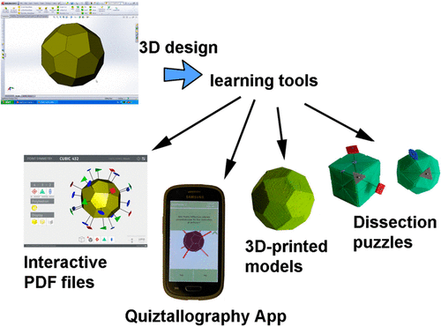

Figure 4 Geology application introduced by Lluis Casa and Eugenia Estop

Geology is only one of the many fields in which the 3D visualisation of virtual models is a plus. Not only that 3D reconstruction is a powerful tool for creating an inventory of findings, but it also is an innovative teaching instrument. Authors Lluis Casas and Eugenia Estop conducted a research project [14] in which students were introduced to virtual 3D models using a mobile application and 3D printed models. Through this approach, students gain a deeper understanding of crystal symmetry and point groups, bridging the gap between theoretical knowledge and practical application, as they were able to study the model as a whole. Users were able to rotate, scale and even section the crystals. Figure 4 illustrates the 3D visualisation feature as presented in the article.

Figure 5 The SfM pipeline used in "Structure from Motion photogrammetry in physical geography"

In the journal article "Structure from Motion photogrammetry in physical geography" [15] the researchers thoroughly explored the practical application of Structure from Motion techniques in physical geography. Utilising a collection of overlapping aerial photographs, they used the photogrammetry technique mentioned before to generate detailed three-dimensional models of geographical features. The results showcased the accuracy and efficiency of SfM in producing complex textured digital representations of landforms, aiding in the analysis of topographic changes and erosion patterns. By demonstrating its capability for capturing accurate 3D models for complex physical landforms, the study highlights SfM as a valuable resource for physical geography researchers. Figure 5 illustrates the pipeline used by the researchers to implement 3D reconstruction, also providing examples along the scheme.

Similar to the previous work is the “Structure from Motion Photogrammetry in Forestry: a Review” journal article [16], studying the particularities of forests using the SfM technique. The methodology uses overlapping images of the forest environment to create 3D models that are instrumental in tasks such as estimating tree heights and assessing the canopy coverage and vegetation health.

Preserving and indexing the heritage is a topic that fascinates scientists worldwide, as it is a key practice not only to showcase historical and natural artefacts but also to enhance a better understanding of our history and environment. The utilization of photogrammetry and 3D scanning has proven transformative in heritage recording, as highlighted in the research paper "Heritage Recording and 3D Modeling with Photogrammetry and 3D Scanning" [17]. This study explores advanced techniques for preserving cultural heritage using high-resolution imagery and precision scanning to generate detailed 3D models of sites and artefacts.

Figure 6 The “Relief” tomb in Cerveteri, Italy

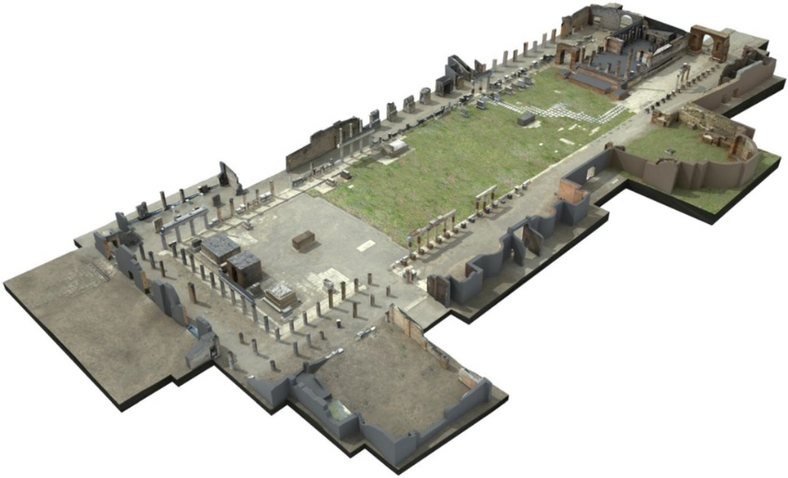

Figure 7 3D Model of the forum in Pompeii

The paper presents various case studies where this approach was employed such as creating virtual models of The “Hanting and Fish” tomb in Tarquinia, Italy, the “Relief” tomb in Cerveteri (Figure 6), Italy, or even an aerial 3D scanning of the forum in Pompeii (Figure 7). Their results are showcasing efficiency in creating digital representations that not only aid preservation but also contribute to historical research, educational initiatives, and virtual experiences. As we seek to explore the applications of 3D modelling and photogrammetry in diverse contexts, this study offers insights into the importance of photogrammetry in providing the opportunity to remotely study fascinating sites from all over the world.

Figure 8 3D models of acquired archaeological artefacts

Similar to the previous use case, the article "Digital Replicas of British Museum Artifacts" [18] published in 2023 demonstrates the power of photogrammetry and virtual environments in digitising and showcasing museum artifacts. In this paper, the authors engaged in creating accurate digital replicas of British Museum artefacts using advanced photogrammetry techniques. The process prioritised the capturing of fine details and textures in order to achieve genuine digital replicas of complex artefacts of different sizes, as presented in Figure 8.

By preserving artefacts as 3D models in a virtual environment, the project contributes to broader accessibility and knowledge dissemination, as the results are accessible to the wide public. The authors discuss how these digital replicas can be utilized for educational purposes, allowing users to interact with historical objects in ways previously unimaginable. This research project perfectly aligns with the project of this report and acts as an inspiration and motivation on how 3D model production and sharing could impact the world.

# Implementation

## 3.1.1. Web Application Implementation Details

The implementation process focused on the user experience. The main idea of the project was to create an accessible and easy-to-use tool, and naturally, the idea of a web application came as a solution as it can be used by both pc users and mobile users. Moreover, a web application is versatile and can be operated on any device that has a browser, even if it is a laptop, an Android smartphone, an iPhone, or a gaming console.

Based on previous experience, the choice for the implementation of such a user interface was the Angular framework. Angular is a JavaScript-based framework that offers rapid development of single-page applications. The application is modular, as the web application encompasses multiple individual components or modules that can exchange information and routes in order to achieve the desired flow inside the application.

Figure 9 AngularJS Application with NodeJS Gateway

To code such components, the programmer needs to write an HTML file that defines the blueprint of the web page, an SCSS file that is responsible for the design and layout and a TypeScript file that incorporates the logic behind the component. TypeScript is a modern class-oriented programming language that is compiled with JavaScript. The compilation of the code is run on a Node.js version 18.16.0 server environment and manages the access to the application routes. Moreover, the application’s packages are being managed, installed, and incorporated using NPM, version 9.5.1. An overview of the architecture is presented in Figure 9.

## 3.1.2 Presentation of the Web Application

Home Page

Register

Login

Dashboard

Upload Video

Upload Images

Portfolio

Explore

Other Portfolios

The hierarchical structure from above describes the user flow inside the application. In the next paragraphs, every component of the user interface would be exemplified and analysed, attaching screenshots from two different types of devices: a Windows laptop using a Chrome-based browser, and an iPhone using a Safari browser.

Figure 10 Laptop (left) and mobile (right) screenshots of the Home Page

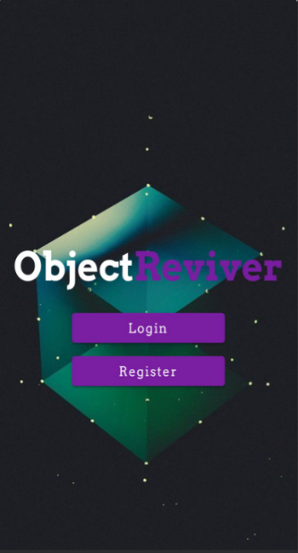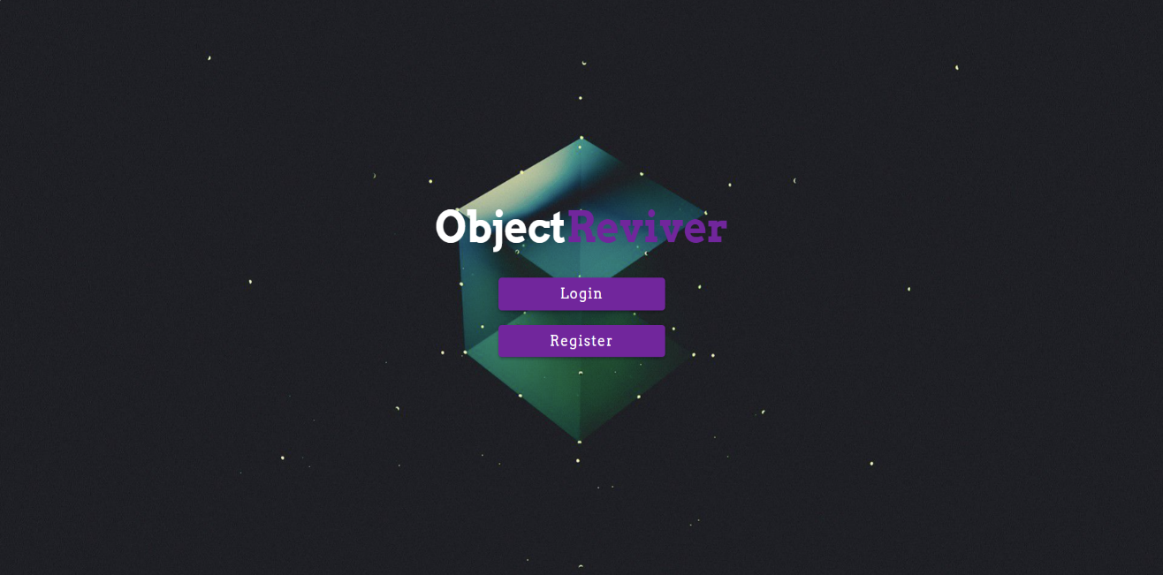

First, when opening the link of the web application, the first thing the user will see is the home page. The home page is presented in Figure 10 using screenshots of the two versions of the web page. As presented in the schema from above, inside the home page there are buttons that open the Login and Register routes. When one of the buttons is clicked, the browser redirects the user to the web component that is responsible for the selected task.

Figure 11 Laptop screenshot of the Login page

Figure 12 Laptop screenshot of the Register page

The Login and Register components have similar structures and designs, as both encapsulate forms where the users type their credentials. The difference between the two pages is that the registration form contains two more input fields for the first and last names of the user, names that will be displayed while exploring the application and will be public to the other users.

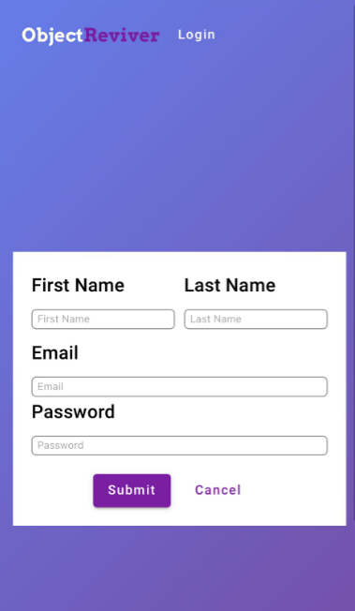

Figure 13 iPhone screenshots of the Login page (left) and the Register page (right)

Figure 11 illustrates the laptop version of the Login page, while Figure 12 presents the laptop version of the Register page. The mobile version is also presented, with screenshots of both pages, in Figure 13.

The login process involves the completion of the input fields for email and password. When finished, the submit button is clicked to complete the authentication. When the button is clicked, the TypeScript unit from the component gets the information from the field and passes them to the backend, using the “/login” route of the API.

In the running process of the Flask backend, the function corresponding to the “GET” HTTP method of the “/login” route is triggered. This function decrypts the credentials passed from the user and sends an enquiry to the database using a MySQL connector. The query checks if the table responsible for the indexation of users contains a pair of user id – password. The result of the search is returned to the backend.

If the search has a result, then the backend returns a favourable message to the frontend. If not, a corresponding message is returned. When the TypeScript unit of the component receives the message, redirects the user to the Dashboard component if the authentication is successful, or remains on the same page if the credentials did not match with the ones from the database.

On the other hand, the Registration does not involve querying the database for a possible match in credentials but creating another entry in the corresponding table. Therefore, after the completion of the input fields of the form and the clicking of the submit button, the TypeScript unit of the registration component sends the information from the form to the “/register” route of the API.

The information is gathered in JSON format by the function responsible for the “POST” HTTP method of the “/register” route. This function creates a MySQL query that inserts the information received in the table that indexes the users with the corresponding values of the columns. After that, the backend sends a message to the frontend according to the successful completion of the task. The registration TypeScript unit will then receive the message, and if the operation is successful than it will redirect the user to the login component.

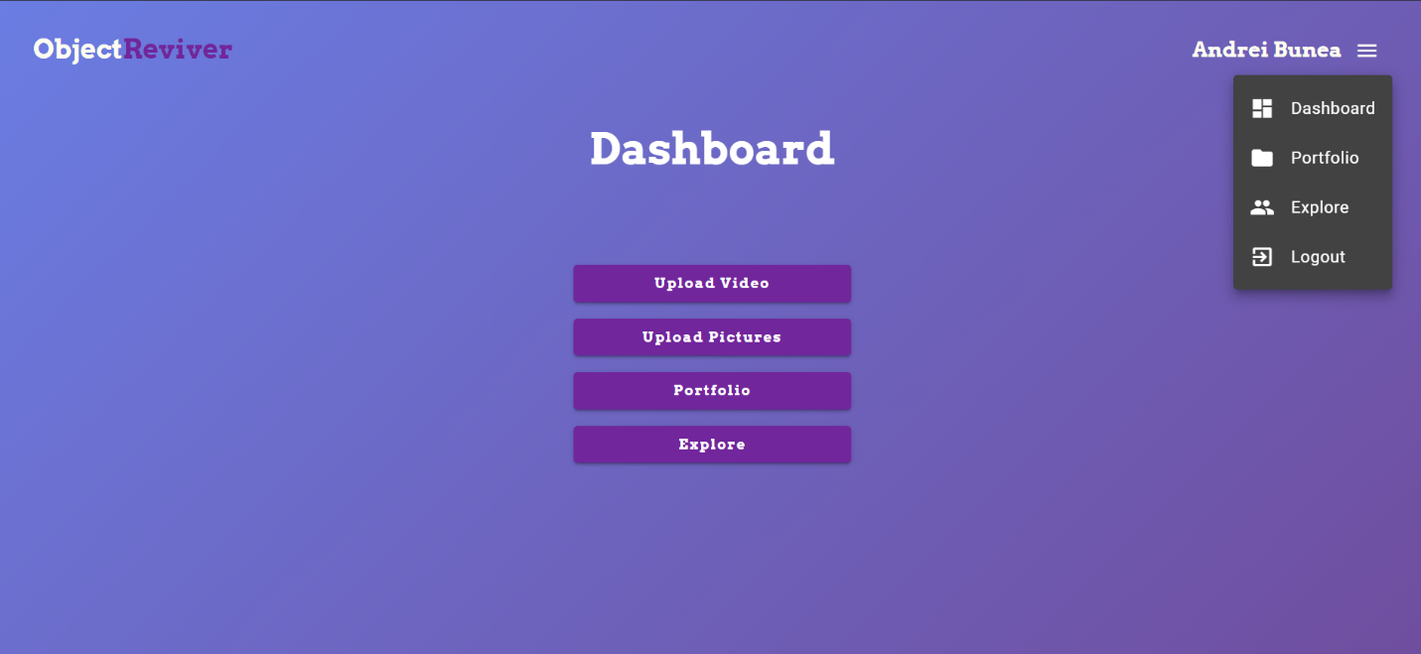

Figure 14 Laptop screenshot of the Dashboard page

The Dashboard is the component that organises every other main component of the application. It presents the main functionalities inside the application and provides buttons with routes to corresponding web pages. The Dashboard page is presented in Figure 12 as the laptop version and in Figure 14 as the mobile version.

Every web page, starting from Dashboard, has a common component: the navbar. This component in situated on the very top of the page and contains the logo of the application, the name of the user that is logged in and a drop down menu. When the three, white parallel lines logo is clicked, the visibility of the menu is triggered. The menu is implemented as a list with the 3 main web pages of the application: Dashboard, Portfolio and Explore, and also the Logout functionality that end the session for the current user and redirects to the home screen. To exemplify the actionable menu, the icon has been clicked in Figure 14.

Figure 15 Mobile screenshot of the Dashboard Page

To explore the functionalities of this web page, the report will analyse each one of the four functionalities offered by the Dashboard page. The first two buttons are intended for initialising the process of 3D model reconstruction. To start the process, the buttons open a modal containing a form where the user needs to upload a video or a set of images, depending on which one of the two buttons he clicked.

ilustrate the two modals, each one corresponding to one of the two buttons. The first of the figures is the uncompleted form for the submission of a video as input data for the reconstruction process, while the second figure depicts the process of uploading a set of pictures and in addition to the first image, the form is completed with an example of inputs.

Figure 16 Upload Video modal

Figure 17 Upload Pictures modal

As observed, the “Upload Video” button opens a modal where the first item to be uploaded is a video file, while the “Upload Pictures” button open a modal where first the user was to upload a set of images from their device. This is the only difference in the structure of the form. All the other items are identical between the two modals. Both of them require the user to upload a preview image. This image is used to present the 3D model to the other users without clicking to interact with the object. It is also used to highlight that the model reconstructed from the uploaded data is still in process of reconstruction, as the construction of the 3D model can take some more time on particular cases. Thus, when the model is still in process of being acomplished, the preview image will signal the future presence of an item in the user’s portfolio.

Another item that is required by the modal is the model name, in order to facilitate a description of the model for the other users to see. Alongside the preview image, this two inputs are the two key factors that describe a 3D model and highlight the difference between an object and the others. The preview image, the name of the model and the path to the model itself are stored in the database, having an unique id that is paired with the id of the user.

After the completion of the form, the “Submit” button triggers the reconstruction process as the information from the form is sent to the API by calling the “/upload/video” or “/upload/images” endpoints.

When the “/upload/video” endpoint of the API is triggered, the corresponding function is responsible for creating an image dataset from the video and send it as input to the Structure-from-Motion script and store the result alongside the preview and model name. To extract the image dataset from the video, the function extracts frames from the video at an interval of 1 second. The extracted frames are saved in the image input folder of the reconstruction script.

The function corresponding to the “/upload/images” HTTP request saves the images directly without running any algorithms on the received image dataset. The images are saved in the same folder as the frames extracted from the video. A very important observation is that every time the reconstruction mechanism in triggered by uploading videos or images, all the directories that contain data from previous inputs are cleared.

After the successful save of the images in the input directory of the reconstruction script, the backend starts the running process of the script that handles and manages the execution of Meshroom using only the command line interface. More about this script will be covered in a section dedicated just for this process.

After the completion of the 3D model, the result is saved in the local memory of the server running the backend, in a directory created just for the user that owns the model. The result of the reconstruction process is an .obj file that contains the scene with the 3D object, an .mtl file that describes the association between texture and vertices of the mesh, and multiple texture files saved in a .png format.

The files descripting the mesh are stored in the local memory of the server, because storing them in the database could alter the information from the files. To store such files in a table requires an encoding of the data, and images and .obj files are sensible to this encoding, as the results of the decoding process can lead to data alteration. However, the directory system of the server is well structured, and the application assures the good storage of the data, preventing the loss of the information and fault access from other users that do now own the directory.

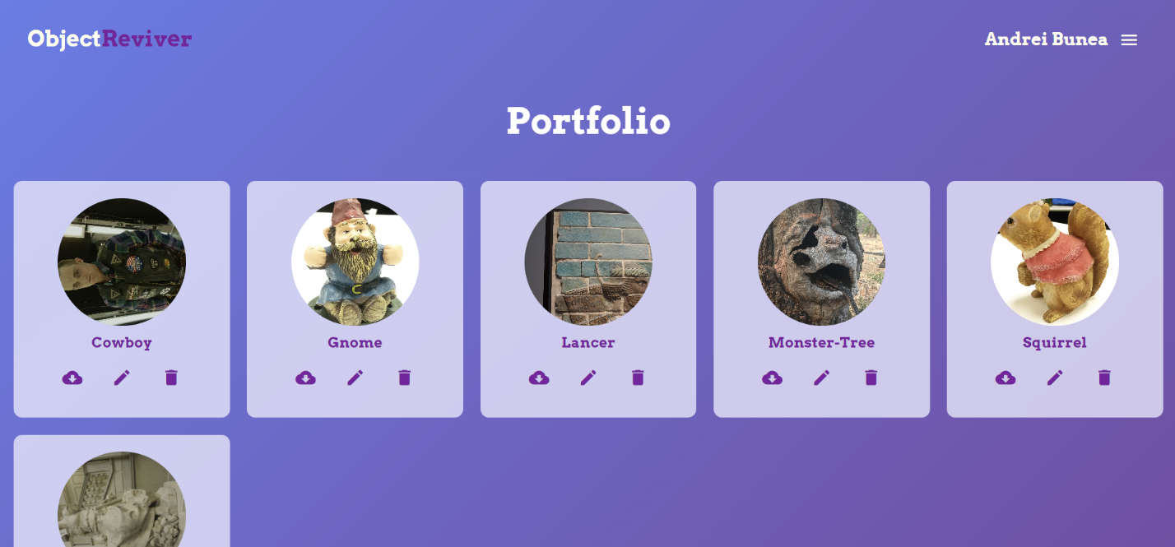

Figure 18 Laptop screenshot of the Portfolio page

Next in line to be discussed is the Portfolio page. This component is designed to present the 3D models created by the user. Every object is displayed in a dynamic grid and is represented by it’s preview image and model name. For each model, under their name, there are 3 icons that represent actions available to the user. The three actions are: downloading the model as a zip archive, edit the model by modifying the preview image or its name, or delete the model from the portfolio. The PC version of the website is illustrated in Figure 18.

Figure 19 Mobile screenshot of the Portfolio page

Looking at both images, it can be observed that the grid used for listing the models is dynamic, adapting the number of items on each row depending on the width of the screen.

Moreover, the Portfolio page offers the opportunity of viewing the 3D model and interact with it. This action is launched by clicking on one of the objects from the list.

Figure 20 Three.js scene of the Alexander the Great model

Figure 21 Three.js scene of the Monster-Tree model

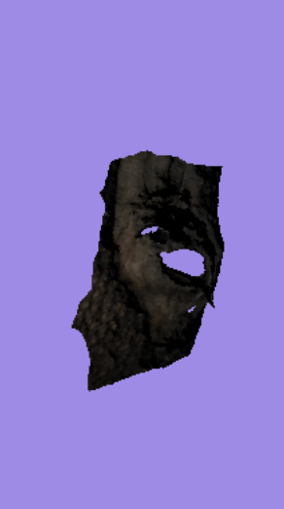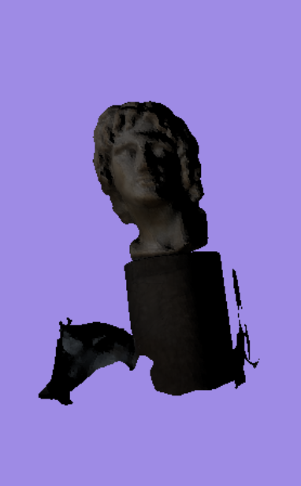

In Figure 20 and Figure 21, some examples of this functionality are presented. In this images, two models were clicked for 3D analysis in the virtual scene of the application: a “Monster-Tree” model and a “Alexander the Great” model. Both models were created using the application and its Structure-from-Motion pipeline.

Moreover, the virtual scene rendered inside the application is responsive to the user actions, and the user can interact with the model by rotating or scaling. These actions are performed by moving the cursor in a direction while holding the click, or the analogue interaction in the case of the mobile version.

The scene is rendered using Three.js inside the Angular application. Three.js is a versatile JavaScript library that empowers the creation of 3D scenes inside applications, providing a simpler version of WebGL tools and functionalities. To achieve this setup for rendering, the TypeScript unit manages the functionalities of the Three.js library.

First, the scene is instantiated using the built-in function ‘THREE.Scene()’, and the colour of the background is established. Now that the scene is defined, a camera needs to be instantiated and positioned. The model preview component uses the ‘THREE.PerspectiveCamera’ with the camera frustum vertical field of view set at 75, camera frustum near plane at 0.1 and camera frustum far plane at 1000. The renderer, a ‘THREE.WebGLRenderer’ instance, is initialized and associated with the HTML container. This renderer is responsible for converting the 3D scene into visible content on the user's screen. The camera's position is set to provide a suitable view of the scene, and a window resize event listener is added to maintain responsiveness. In addition, a directional light is inserted in the scene in order to lighten the 3D models.

Next, the model needs to be loaded from its datafiles and rendered inside the scene. The THREE.js loaders ‘OBJLoader’, ‘MTLLoader’, and ‘TextureLoader’ retrieve data from the .obj, .mtl, and texture files, respectively. After the mesh is correctly constructed and the textures are mapped accordingly, the 3D object is added to the scene.

Figure 22 Rotated model of a statue using Orbit Controls

The interaction is provided by adding Orbit Controls from the THREE.js library, allowing users to explore the 3D scene. These controls come with various parameters for damping, rotation speed, and zooming. Their event listeners ensure that user actions trigger the correct modifications to the rendered scene. An example is illustrated in Figure 22.

In addition, an animation loop is implemented, refreshing at every frame. Within this loop, the ‘controls.update()’ method keeps the controls responsive, and the render function is invoked to refresh the scene rendering. This dynamic combination brings life to the 3D model, making it interactive and engaging.

This model preview component not only allows user to interact with the scanned item, but also provides the opportunity of quickly observing the correctness of the model. Thinking of an use case of the application where the user uploads a dataset of images for reconstruction, accessing this feature at the end of the SfM process indicates if the results are satisfying or if the user should try again, using another set of images. By using this feature, the user can learn which parts of objects to focus on when taking pictures, paying attention to specific details.

# References

|  |  |
| --- | --- |
| [1] | “Unity Asset Store,” [Online]. Available: https://assetstore.unity.com/. |
| [2] | “Sketchfab,” [Online]. Available: https://sketchfab.com. |
| [3] | T. Schenk, “Introduction to Photogrammetry,” *The Ohio State University, Columbus,* 2005. |
| [4] | A. &. A. F. M. &. M. M. Jebur, “3D City Modelling by Photogrammetric Techniques,” 2017. |
| [5] | D. V. J. K. R. W. Ruinian Jiang, “Close-range photogrammetry applications in bridge measurement: Literature review,” *Measurement,* pp. 823-834, 2008. |
| [6] | E. M. B. J. S. &. M. J. C. Mikhail, Introduction to modern photogrammetry, John Wiley & Sons, 2001. |
| [7] | “Archeological Institute of America,” [Online]. Available: https://www.archaeological.org/fieldwork/archaeological-photogrammetry/. |
| [8] | J. B. N. G. M. H. J. R. M.J. Westoby, “‘Structure-from-Motion’ photogrammetry: A low-cost, effective tool for geoscience applications,” *Geomorphology,* vol. 179, no. 2012, pp. 300-314. |
| [9] | Meta, [Online]. Available: https://about.fb.com/news/2020/09/introducing-oculus-quest-2-the-next-generation-of-all-in-one-vr/. |
| [10] | A. a. S. G. Eltner, “Structure from motion photogrammetric technique,” *Developments in Earth surface processes,* 2020. |
| [11] | “Meshroom,” AliceVision, [Online]. Available: https://github.com/alicevision/Meshroom. |
| [12] | C. G. S. C. L. G. P. C. F. M. B. D. L. G. a. L. Y. Griwodz, “AliceVision Meshroom: An open-source 3D reconstruction pipeline,” in *Proceedings of the 12th ACM Multimedia Systems Conference*. |
| [13] | I. E. a. A. Kuqi``, “Analyzing parameters in 3D reconstruction photogrammetry in Meshroom, a case study,” in *11th Mediterranean Conference on Embedded Computing (MECO)*, 2022. |
| [14] | L. a. E. E. Casas, “Virtual and Printed 3D Models for Teaching Crystal Symmetry and Point Groups,” *Journal of Chemical Education,* 2015. |
| [15] | M. W. C. J. L. &. Q. D. J. Smith, “ Structure from motion photogrammetry in physical geography,” *Progress in Physical Geography: Earth and Environment.* |
| [16] | J. C. C. P. S. P. L. O. J. a. R. J. Iglhaut, “Structure from Motion Photogrammetry in Forestry: a Review,” *Current Forestry Reports,* 2019. |
| [17] | F. Remondino, “Heritage recording and 3D modeling with photogrammetry and 3D scanning,” *Remote Sensing,* 2011. |
| [18] | G. B. P. G. T. F. M. J. a. S. A. Patrucco, “DIGITAL REPLICAS OF BRITISH MUSEUM ARTEFACTS,” *The International Archives of the Photogrammetry, Remote Sensing and Spatial Information Sciences,* 2023. |
| [19] | I. a. K. A. Enesi, “Evaluation of the 3D Reconstruction Performance of Objects in Meshroom: A Case Study”. |